**Exercises about users and groups management**

NOTE 1: We have to start a root session to do the exercises

NOTE 2: Take into account that user and group names are CASE SENSITIVE

1. Add two new groups named “daw” and “crey”

sudo addgroup daw ; sudo addgroup crey

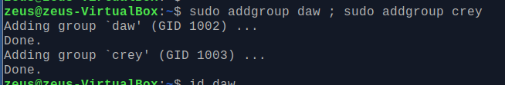

1. Change “daw” and “crey” GIDS to 2001 and 2002, respectively.

sudo groupmod -g 2001 daw && sudo groupmod -g 2002 crey



1. Create a new group called “profesores” with GID of 2000. Then, modify the group name to teachers

sudo groupadd -g 2000 profesores; sudo groupmod -n teachers profesores

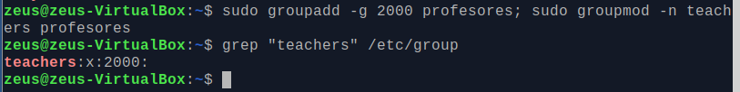

1. Verify that you have correctly created the groups named “daw”, “crey” and “teachers”

grep 2000 /etc/group; grep 2001 /etc/group; grep 2002 /etc/group

grep “daw” /etc/group; grep “crey” /etc/group; grep “teachers” /etc/group

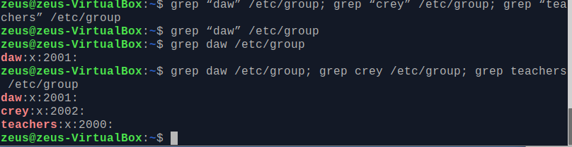

1. Add a new user named “john” whose primary group is “crey”. Has the home directory been created with the default command?

useradd -g crey John # adding to group crey and no home directory is create

useradd -g crey -m john # home is not create

useradd -r John # deleting a user



1. Add a new user named “mary”, whose primary group is “daw” and the home directory /home/mary

useradd -g daw -d “/home/mary” mary·

useradd -g daw -m” mary·

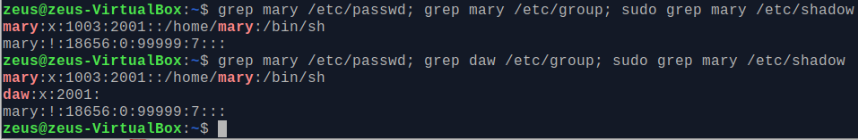

1. Add a new user named “martha”, whose primary group is “teachers”, the home directory

adduser -g teachers -G crey -m martha·# adding Martha primary group teachers secondary group “crey” and automatic home creation

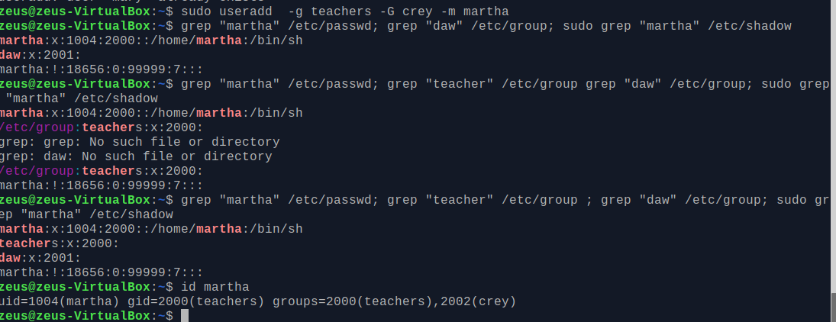

1. Add the following names to the users that you have just created:
   1. John= “John Doe”
   2. Mary = “Mary Williams”
   3. Martha = “Martha Jones”

sudo usermod -c "john Doe" john && sudo usermod -c "mary Williams" mary && sudo usermod -c "artha Jones" martha

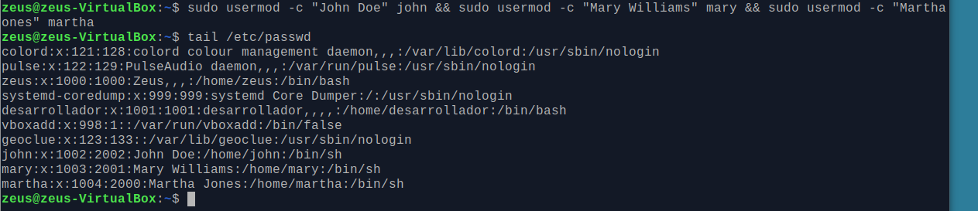

1. How could you check that you have created all the users with the right primary groups?

tail -3 /etc/passwd

or

for user in john mary martha; do id "${user}"; done

uid=1002(john) gid=2002(crey) groups=2002(crey) # only primary group

uid=1003(mary) gid=2001(daw) groups=2001(daw) # only primary group

uid=1004(martha) gid=2000(teachers) groups=2000(teachers),2002(crey) # primary and secondly group



1. Verify if crey and daw groups have martha as a member

grep "crey" /etc/group ; grep "daw" /etc/group



1. Can you log in with any of the users you have created?

No.

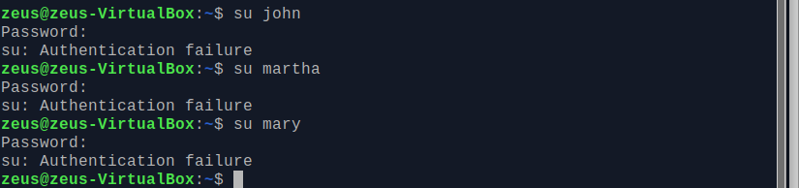

1. Set the password “martha22” for the user “martha”

sudo passwd martha

[sudo] password for zeus:

New password:

Retype new password:

passwd: password updated successfully

su – Martha # to loging into Martha’s directory, no primitive shell

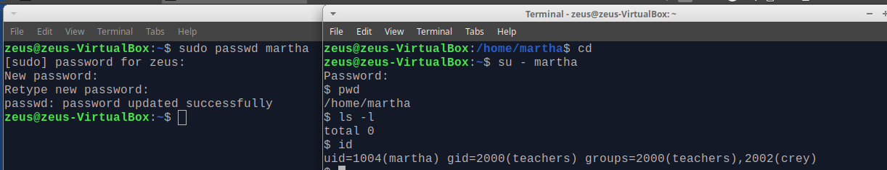

1. Display on the shell prompt the groups to which Martha belongs

id martha

uid=1004(martha) gid=2000(teachers) groups=2000(teachers),2002(crey)

tail -n 3 /etc/group

daw:x:2001:

crey:x:2002:martha

teachers:x:2000:



1. Create a directory named “teachers” in “/home”. Then, assign the directory “/home/teachers” to the user martha (you can do all the steps typing just one command).

**sudo usermod -d /home/teacher -m martha**

usermod: user martha is currently used by process 3069

sudo pkill -9 -u martha

This shut the terminal open a new terminal and

**sudo usermod -d /home/teacher -m Martha** # home directory is created

grep "martha" /etc/passwd

martha:x:1004:2000:Martha Jones:/home/teacher:/bin/sh

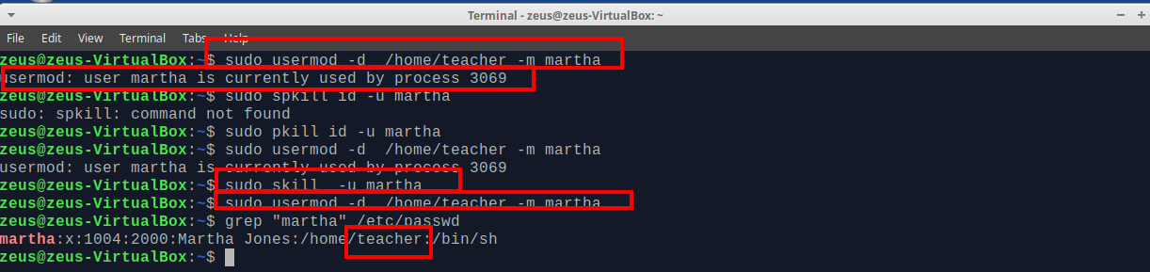

1. Now, log in as user “martha”. Run the command “cd $SHOME” and check that the home directory is “/home/teachers”



1. Go back to the root shell



1. Change the shell of the user named “john” to “sh”

sudo usermod -s sh john

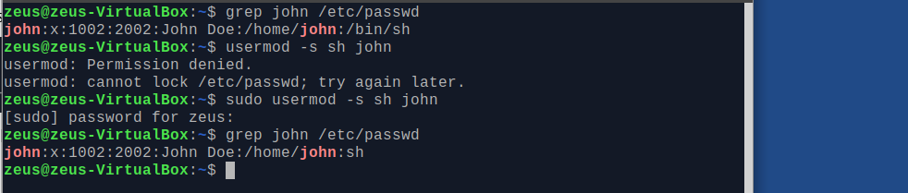

1. Add the user “martha” to the secondary group “daw” without removing the already assigned secondary groups.

sudo usermod -G daw -a Martha



1. Run a command to print the following information for each user

|  |  |  |
| --- | --- | --- |
| User | Primary group | Secondary groups |
| john | crey |  |
| mary | daw |  |
| martha | teachers | crey, daw |

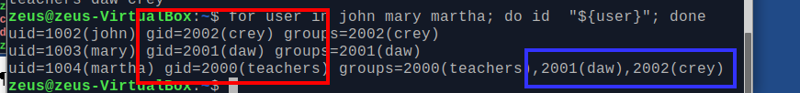

1. Delete all the groups you have created. Could you delete them? Why?

No, because, it cannot be removed the primary groups of any existing user. First it must be remove the thr user and then the group.

sudo groupdel <user>



1. Delete all the users you have created, including the files and directories inside the home.

For loop for as root execute

for user in john mary martha; do userdel -r "${user}"; done

for user in john mary martha; do userdel -r -f "${user}"; done

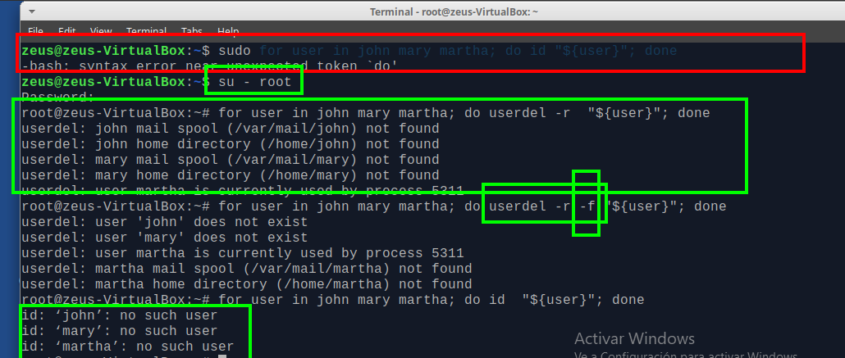

**-f:** This option forces the removal of the specified user account. It doesn’t matter that the user is still logged in. It also forces the userdel to remove the user’s home directory and mail spool, even if another user is using the same home directory or even if the mail spool is not owned by the specified user

**-r:** remove the files in the user’s home directory along with the home directory itself and the user’s mail spool. All the files located in other file systems will have to be searched for and deleted manually.

**-R:** This option apply changes in the CHROOT_DIR directory and use the configuration files from the CHROOT_DIR directory.

**-Z :** remove any SELinux policies.

1. Try again to delete the groups

For loop for as root execute

for user in daw crey teachers; do groupdel "${user}"; done

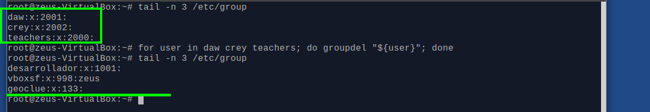

**References:**

<https://linux.die.net/man/8/groupdel>

<https://linux.die.net/man/8/useradd>

<https://kb.iu.edu/d/adwf> (find users by uid)

<https://unix.stackexchange.com/questions/248426/add-multiple-user-to-unix-group-in-one-line>

<https://www.cyberciti.biz/tips/howto-linux-kill-and-logout-users.html>

<https://www.geeksforgeeks.org/userdel-command-in-linux-with-examples/>